**LCD**

A liquid-crystal display (LCD) is a [flat panel display](http://en.wikipedia.org/wiki/Flat_panel_display), [electronic visual display](http://en.wikipedia.org/wiki/Electronic_visual_display), or [video display](http://en.wikipedia.org/wiki/Video_display) that uses the light modulating properties of [liquid crystals](http://en.wikipedia.org/wiki/Liquid_crystal). Liquid crystals do not emit light directly.

LCDs are available to display arbitrary images (as in a general-purpose computer display) or fixed images which can be displayed or hidden, such as preset words, digits, and [7-segment](http://en.wikipedia.org/wiki/7-segment) displays as in a [digital clock](http://en.wikipedia.org/wiki/Digital_clock). They use the same basic technology, except that arbitrary images are made up of a large number of small [pixels](http://en.wikipedia.org/wiki/Pixel), while other displays have larger elements.

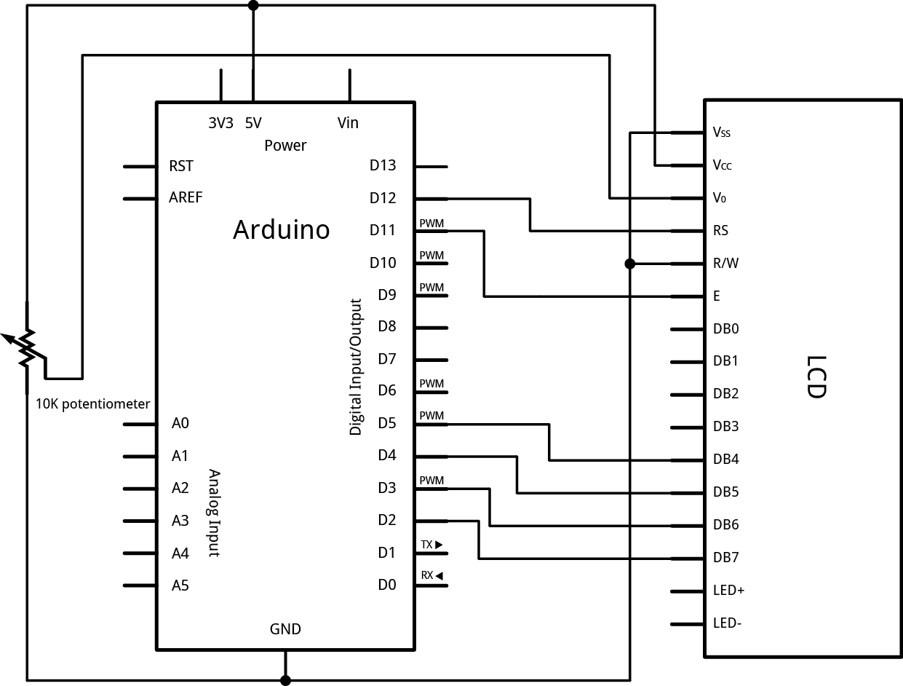

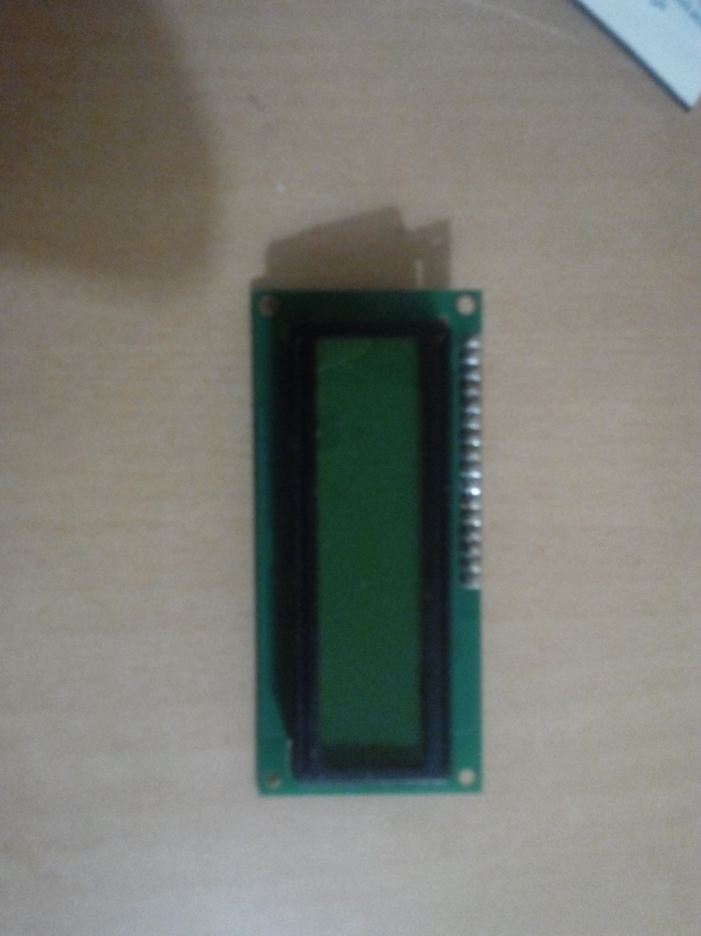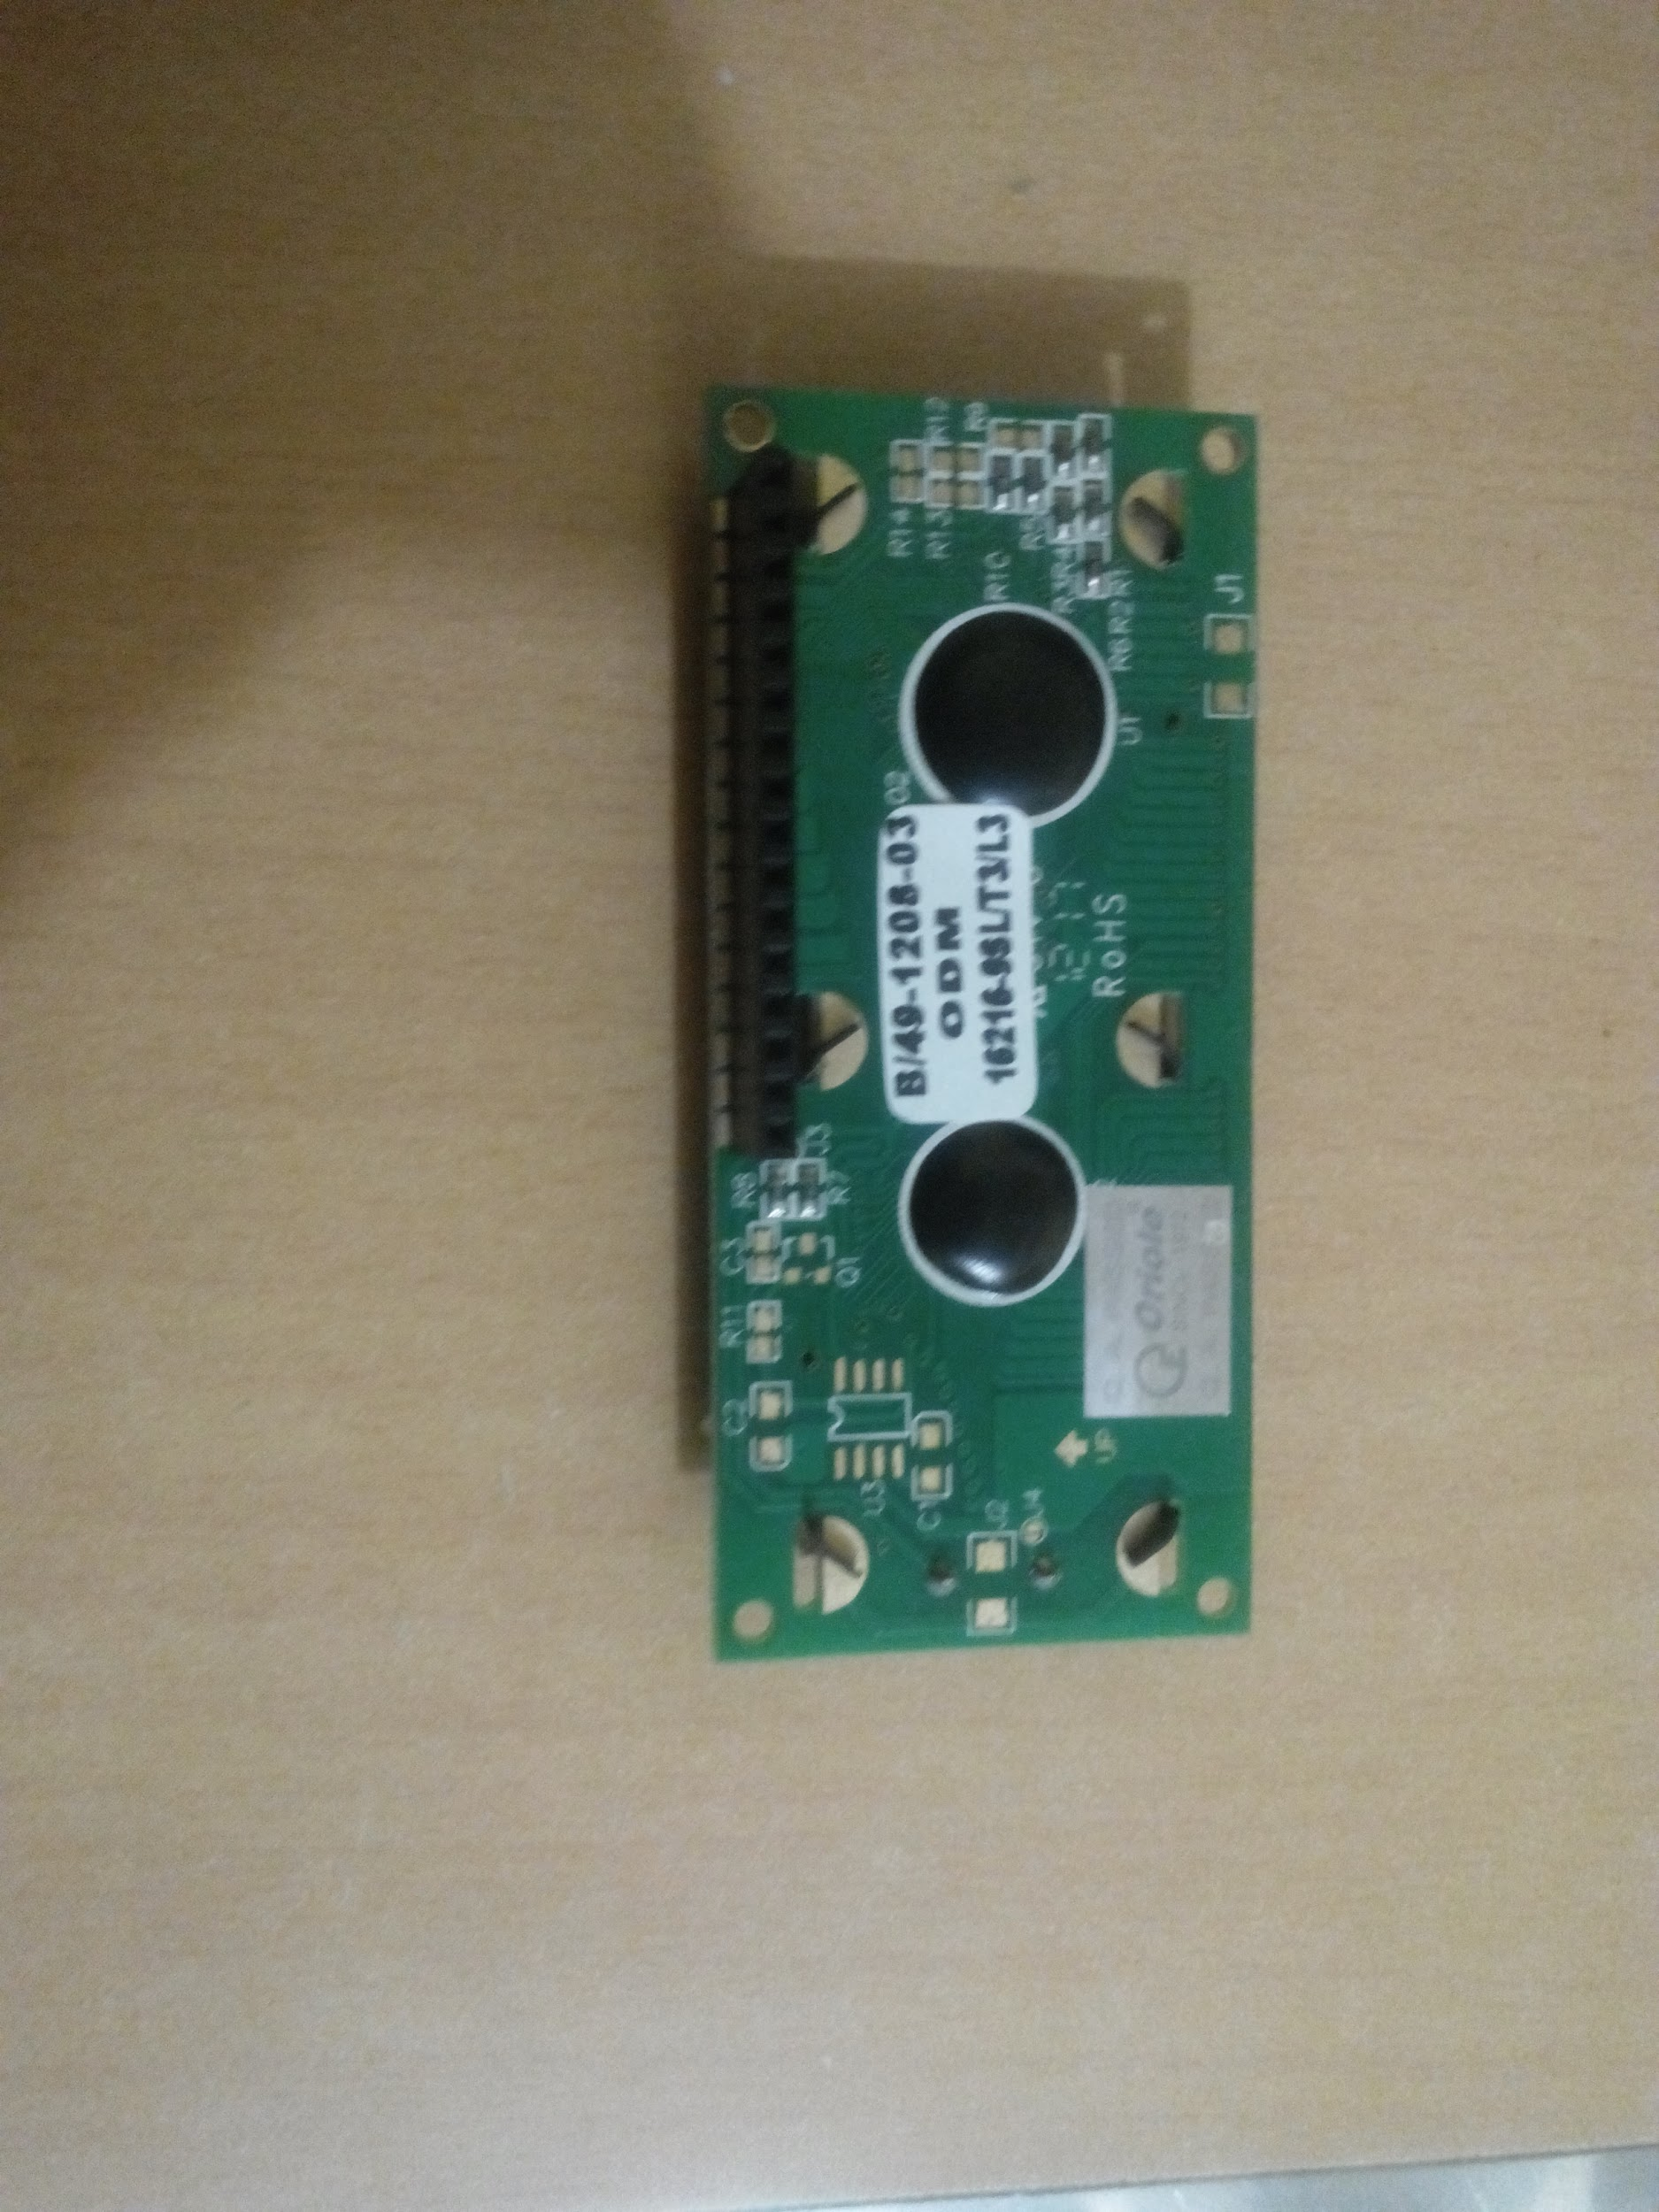

Learning : <http://arduino.cc/en/Tutorial/LiquidCrystal>

LCD Arduino Library : <http://arduino.cc/en/Reference/LiquidCrystal>